Regino Jr Allan V.

BSIT-4F

Students

1. Create a Student

* Method: POST
* Endpoint: /students
* Request Body:

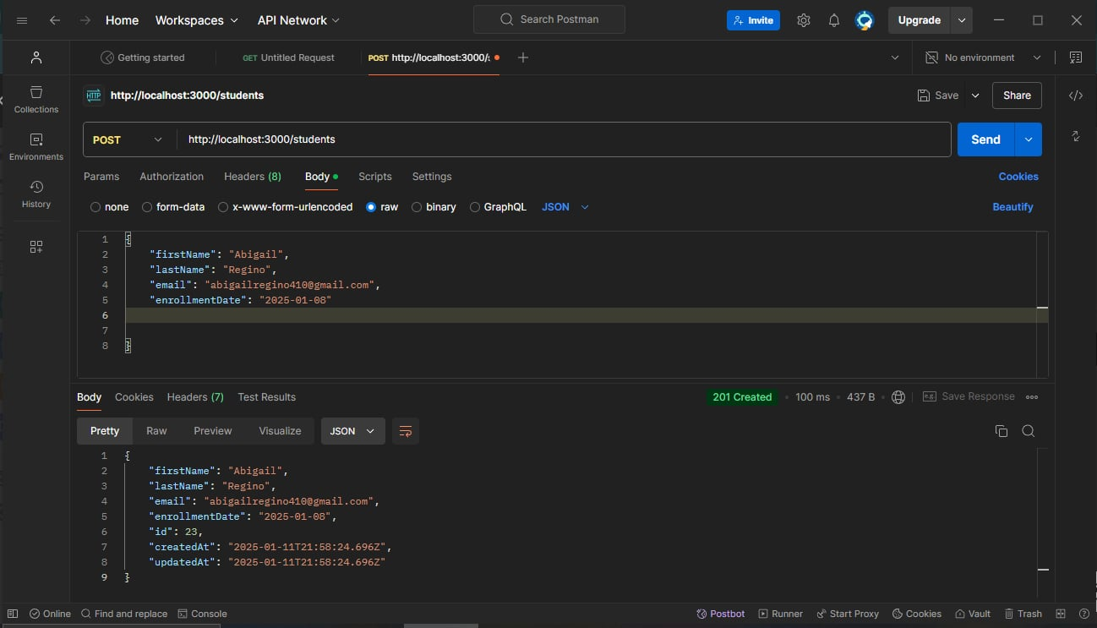

Get All Students

* Method: GET
* Endpoint: /students
* Response:
* Status: 200 OK
* Body

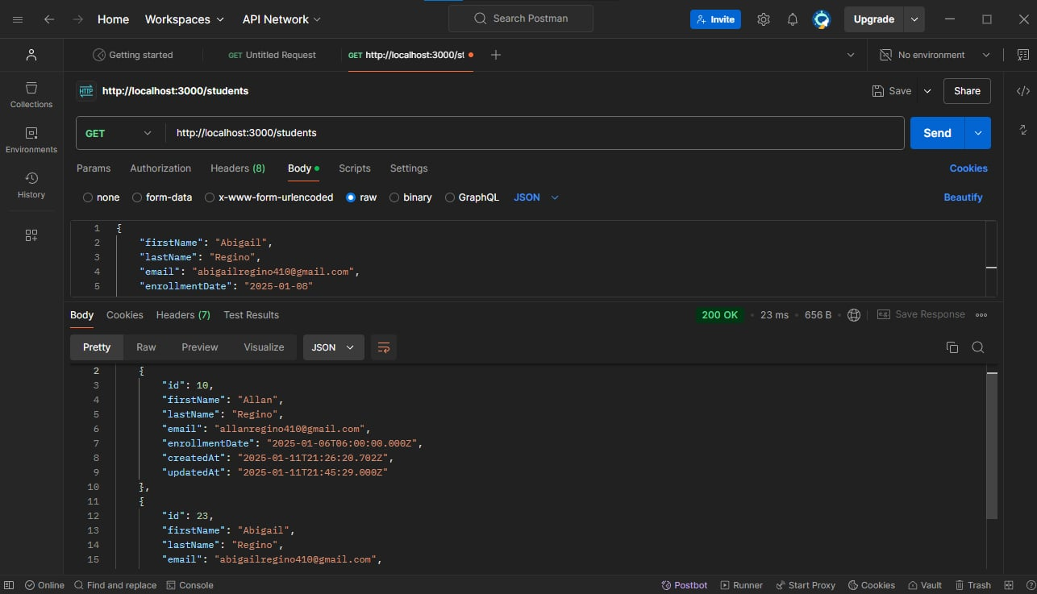

Get a Single Student

* Method: PUT
* Endpoint: /students/:id
* Response:
* Status: 200 OK
* Body

